#setup jenkins master server

3 yum install java-11-amazon-corretto.x86_64

4 yum install git -y

5 mkdir server

6 cd server/

7 wget https://dlcdn.apache.org/tomcat/tomcat-9/v9.0.89/bin/apache-tomcat-9.0.89.zip

8 ll

9 unzip apache-tomcat-9.0.89.zip

10 rm -rf apache-tomcat-9.0.89.zip \

11 rm -rf apache-tomcat-9.0.89.zip

12 ll

13 cd apache-tomcat-9.0.89/

14 ll

15 cd webapps/

16 wget https://get.jenkins.io/war-stablewar/latest/jenkins

17 wget https://get.jenkins.io/war-stable/latest/jenkins.war

18 ll

19 cd ../

20 chmod -R 777 apache-tomcat-9.0.89/

21 cd apache-tomcat-9.0.89/

23 cd bin/

24 ./startup.sh

25 cat /root/.jenkins/secrets/initialAdminPassword

#after Jenkins setup access Jenkins dashboard

Create job first : by using pipline

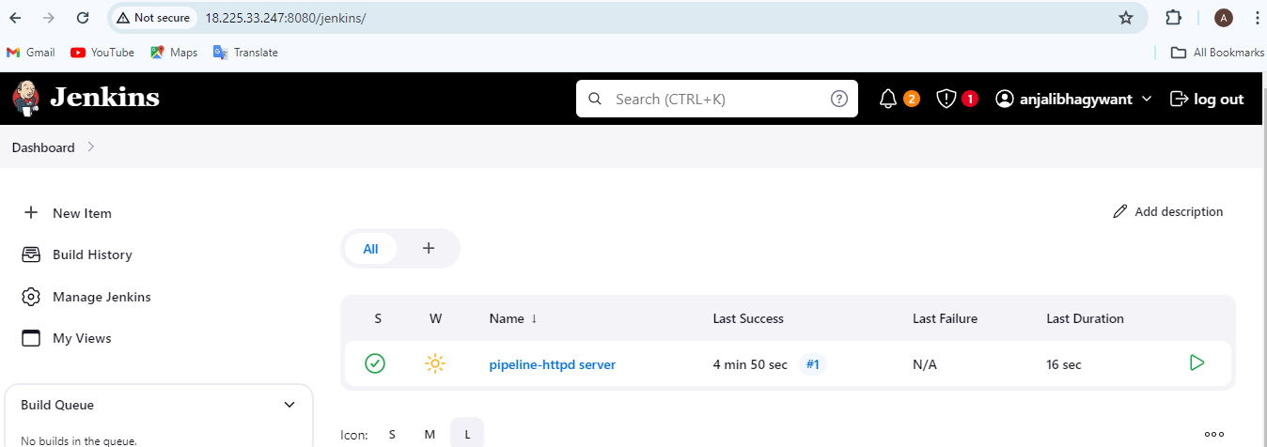

Scripts : declarative pipeline

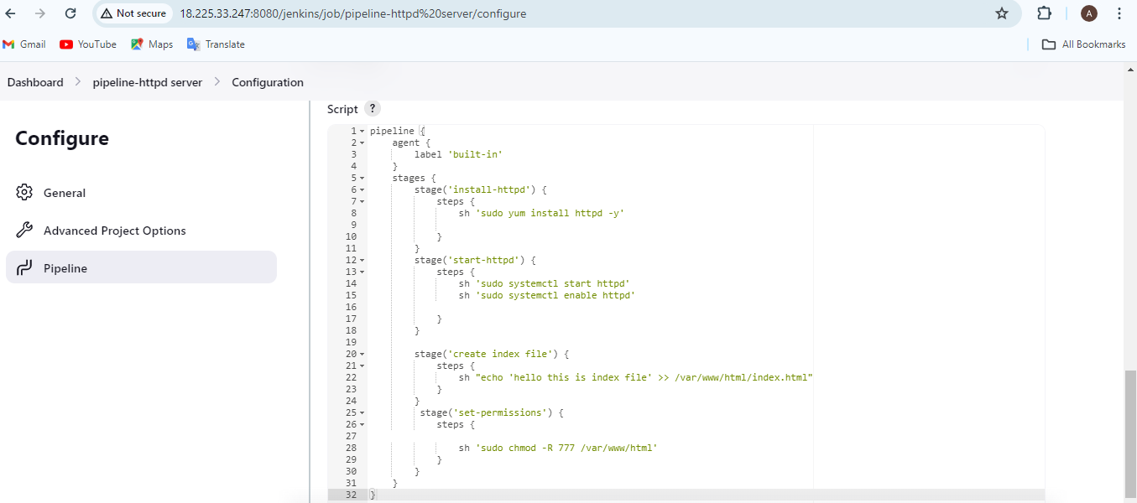

output

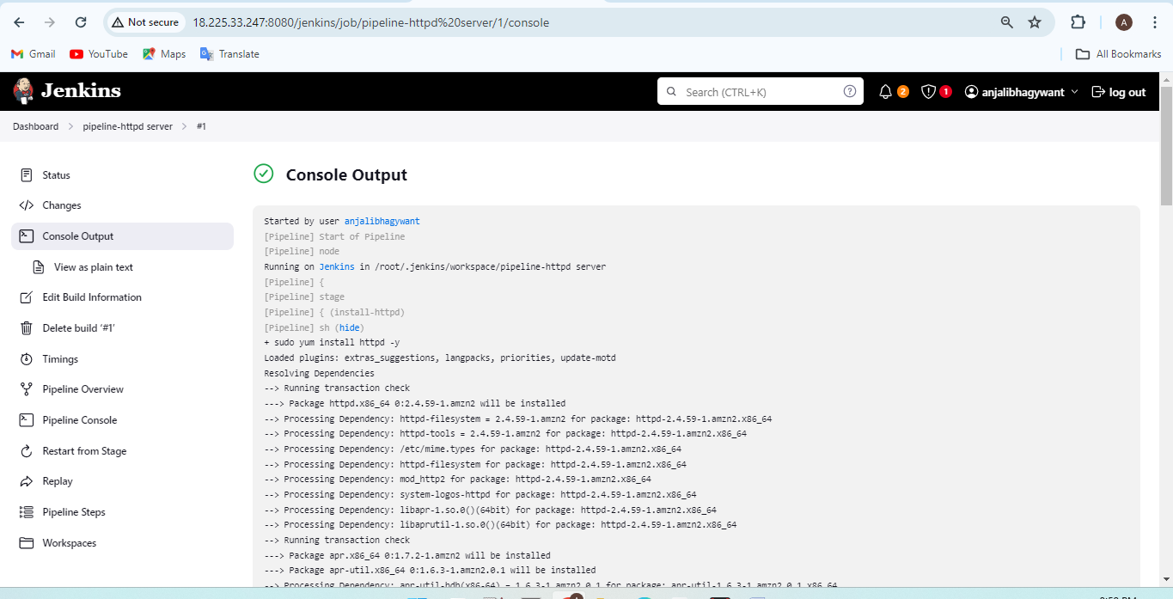

output

